**ITITIU19228 – REPORT LAB 3 CA**

**Question 1.1:**

* The MIPS code i modified in **lab3_1_1.s** please check it help me

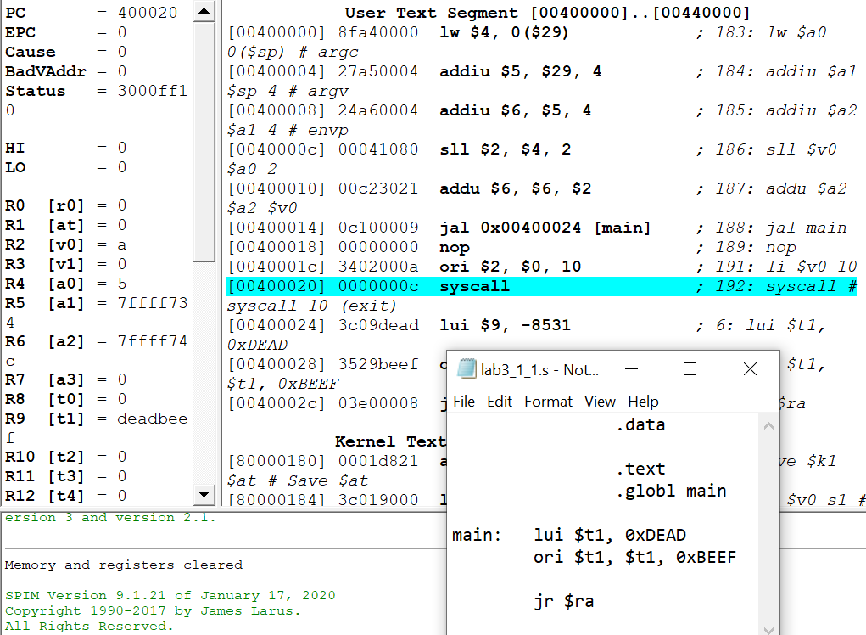

**Question 1.2:**

* The MIPS code i modified in **lab3_1_2.s** please check it help me

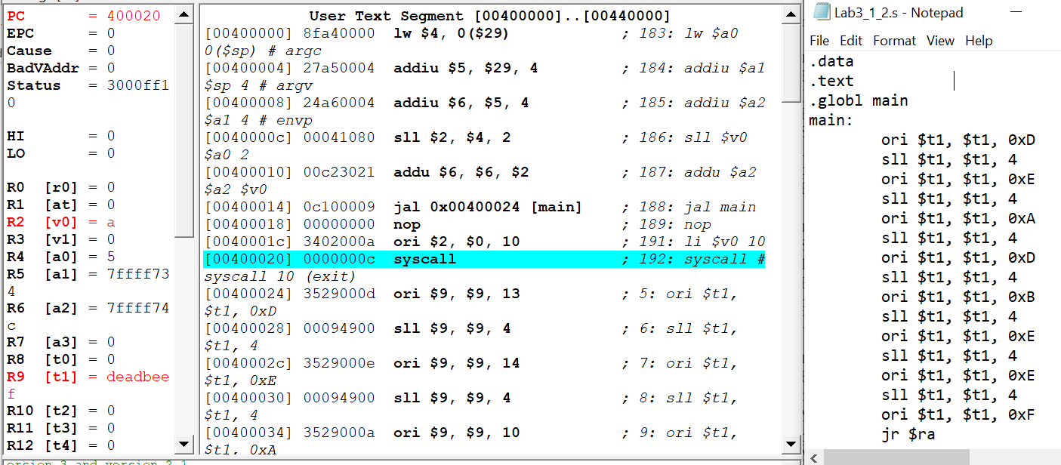

**Question 1.3:**

* The MIPS code i modified in **lab3_1_3.s** please check it help me

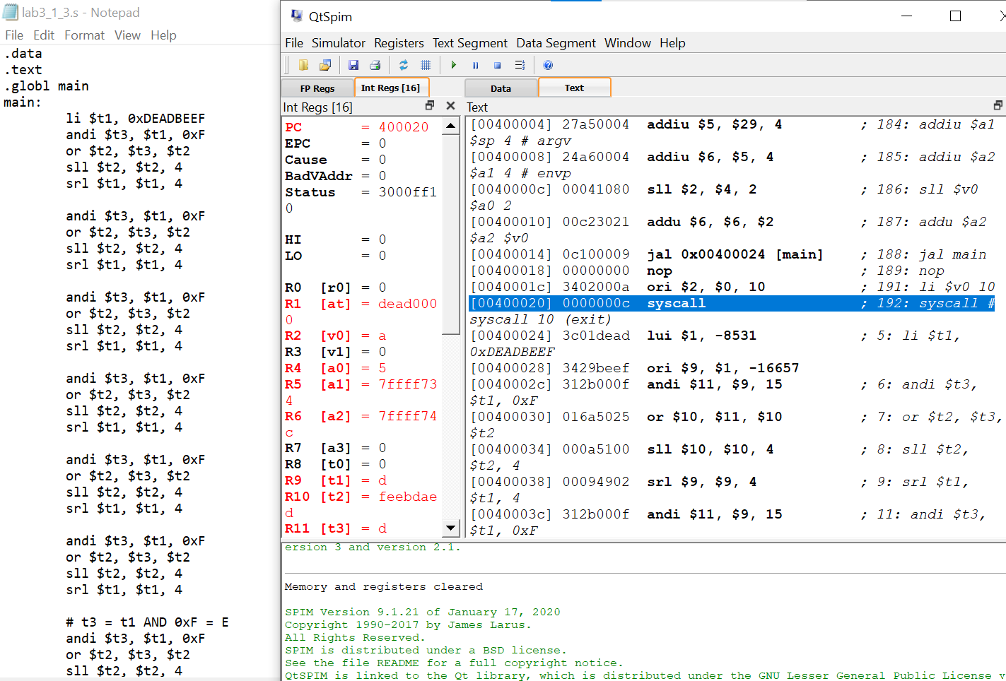

**Question 1.4**

* The MIPS code i modified in **lab3_1_4.s** please check it help me

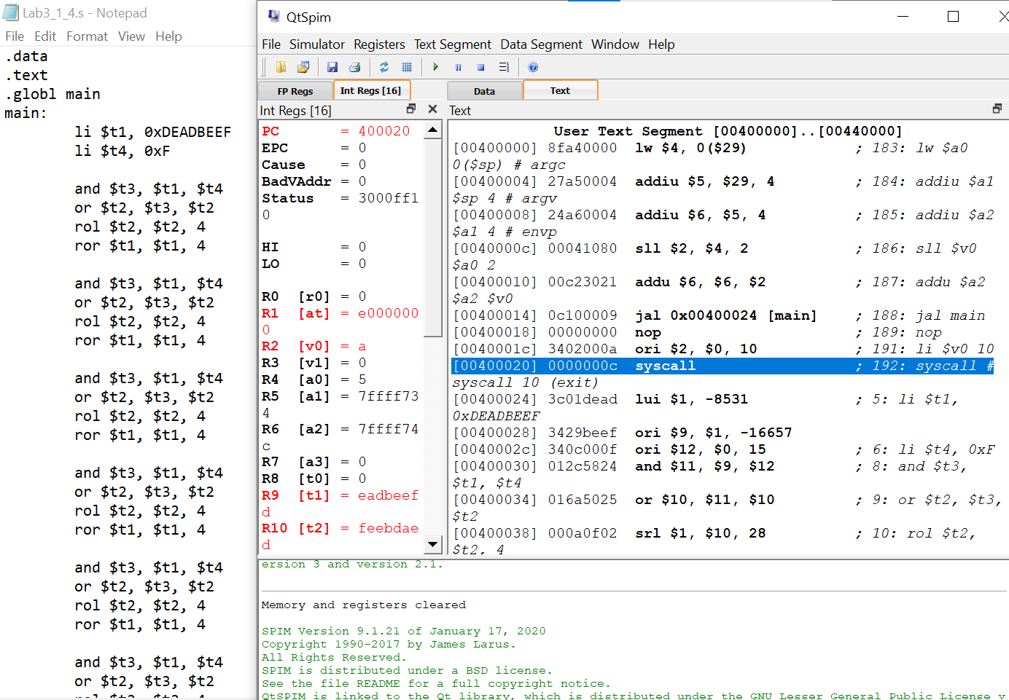

Question 2.1:

* The MIPS code i modified in **lab3_2_1.s** please check it help me

Question 2.2:

* The MIPS code i modified in **lab3_2_2.s** please check it help me

